1. **Agenda**:
   1. We will build base implementation framework using Apache Camel within using Spring Container.
   2. We will start by going over the basics and the concepts how Camel treats and processes the routes.
2. We have to start by going over the basics and the concept on how camel treats and processes the so-called routes.
3. Route is nothing but flow definition of Camel Exchange with optional intermediate optional steps such as transformation, enrichment, aggregation, correlation etc. (these are achieved through the processors, beans, convertors).
4. Spring boot container initiates something called **Camel Context.**
5. Camel Context is a framework built to understand **Camel specific language called DSL**.  
   DSL can be defined in XML, Core Java Format via which we define routes.
6. Route is nothing but flow definition of reading data from an endpoint and send it to another endpoint.
7. The data within a route is encapsulated in something called an **Exchange Object** which has certain properties and an ID.
   1. It has in-message and out-message format.
   2. In-message = headers + body (same in out-message).
   3. The advantage is that we can see what is sent to this route and what is being sent out of this route.
8. 
9. 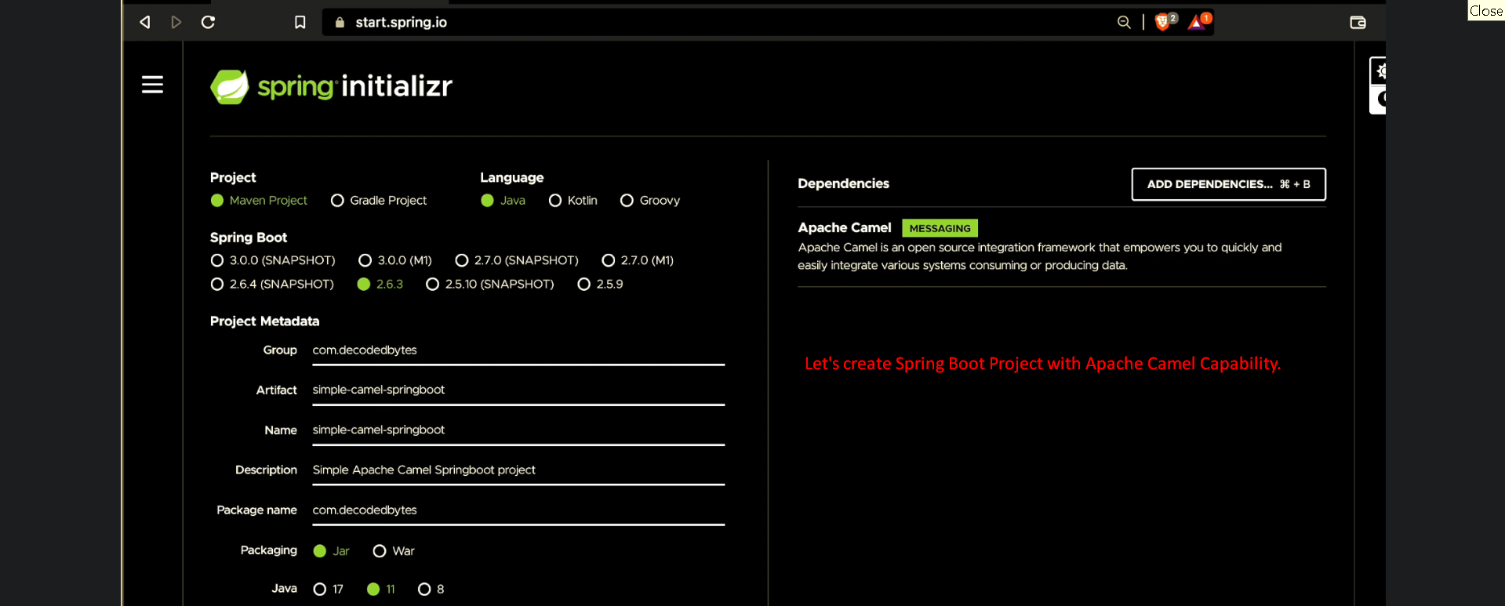  
     
   
10. 